Patient Name : | ARIZ ANSARI | Gender : Male
Age : | 0 Y 6 M | Date : Feb 16, 2024
Referring Doctor : | DR RAMAN KUMAR MD | Patient ID : 2149

MRI BRAIN
PROTOCOL
Multiplanar and multi-echo MRI of the brain was performed without administration of intravenous contrast.
FINDINGS:
POSTERIOR FOSSA:
- Cerebellum and brainstem are normal. Cerebellar folia are normal. No evidence of tonsillar herniation.
- Pons and medulla show normal signal intensity.
- Basal and CP angle cisterns are normal. Fourth ventricle is central and is normal in shape.
- Bilateral mastoid air cells are normal.
SELLA:
- The pituitary gland shows a normal shape, appearance and signal intensity pattern. Stalk is in the midline.
- Cavernous sinuses are normal in size. Supra sellar and chiasmatic cisterns are normal.
- Sphenoid sinus appears normal. Visualized basal cisterns are within normal limits.
SUPRATENTORIAL:
- Multiple Periventricular and sub-ependymal nodules ( Heterotopia ) and periventricular and subcortical T2 /FLAIR hyperintensities involving bilateral cerebral hemisphere.
- Rest of Both the cerebral hemispheres are normal in signal intensity and grey and white interface is well maintained.
- Basal ganglia and thalamus appear normal. Bilateral insular cortex and Sylvian fissures appear normal.
- Midline septa not shifted. No evidence of brain herniation.
- CSF spaces and fissures are well maintained. No evidence of extra-axial collection is seen.
- Flow voids of the major vessels are well seen.
- Paranasal sinuses are well pneumatized without any fluid collection/mucosal thickening.
IMPRESSION:
- Multiple Periventricular and sub- ependymal nodules (Heterotopia) and periventricular and subcortical T2 /FLAIR hyperintensities involving bilateral cerebral hemisphere.

- Evaluation of Neurocutaneous syndrome - possibility of Tuberous sclerosis to be considered.

Suggested clinical correlation.
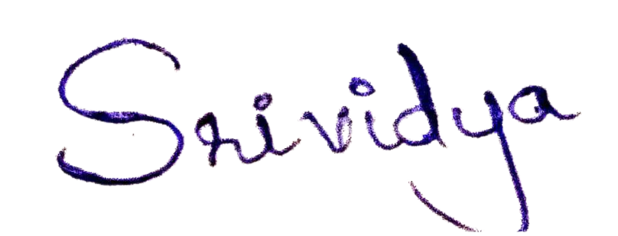
Dr. Srividya Bt
MBBS, MD (Delhi) Consultant Radiologist
Reg - KMC 103375

